**Assignment on RDBMS concepts-morning**

**1. Find the functional dependencies for the below and normalize it till BCNF :**

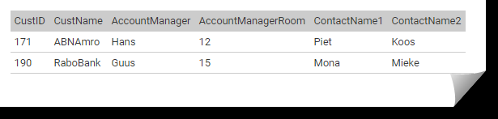

Functional dependencies:

CustID-> CustName

CustID->AccountManager

CustID->AccountManagerRoom

CustID->ContactName1

CustID->ContactName2

AccountManager->AccountManagerRoom

Closure of CustID=CustID, CustName, AccountManager, ContactName1,ContactName2= CustID, CustName, AccountManager, ContactName1,ContactName2,AccountManagerRoom

So candidate key is CustID.

Already in 1NF and 2NF.

But there is a transitive dependency as AccountManagerRoom depends upon AccountManager and AccountManager depends on CustID.

So we’ll spilt it into two.

Customer(CustID,CustName,AccountManager,ContactName1,ContactName2)

Account(AccountManager,AccountManagerRoom)

Above relation is in BCNF.

**2. Draw an ER diagram for a hospital management system.**

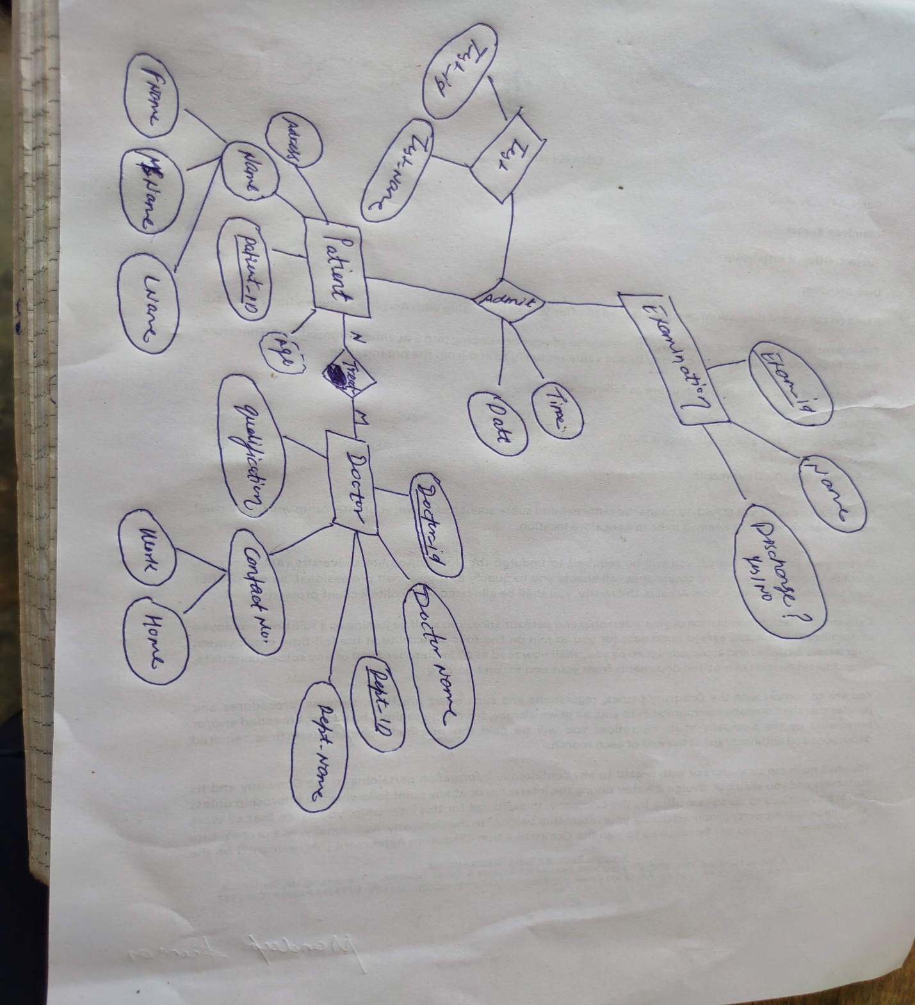

**3.Consider a relation Student (StudentID, ModuleID, ModuleName, StudentName, StudentAddress, TutorId, TutorName). Each student is given a StudentID and each module given a ModuleID. A student can register more modules and a module can be registered by more students. TutorID is the ID of the student's personal tutor, it is not related to the modules that the student is taking. Each student has only one tutor, but a tutor can have many tutees. Different students can have the same name. Different students can be living at the same address.**

**Find all the functional dependencies holding in this relation and normalize the table to 3NF.**

Functional dependencies:

StudentID->StudentName

StudentID->StudentAddress

StudentID->TutorID

StudentID->TutorName

ModuleID->ModuleName

TutorID->TutorName

Candidate key? StudentID, ModuleID (If find closure of StudentID and ModuleID , we’ll get all attributes of the relation).

Not in 2NF

Student(StudnetID, StudentName,TutorID,TutorName,StudentAddress)

Module(ModuleID, ModuleName)

And one for mapping between candidate keys

Student_Module_mapping(StudentID, ModuleID)

Not in 3NF as there is a transitive dependency for TutorID and TutorName

**Student(StudentID,StudentName, StudnetAddress)**

**Tutor(TutorID,TutorName)**

**Module(ModuleID, ModuleName)**

**Student_Module_mapping(StudnetID, ModuleID)**

**3.**